

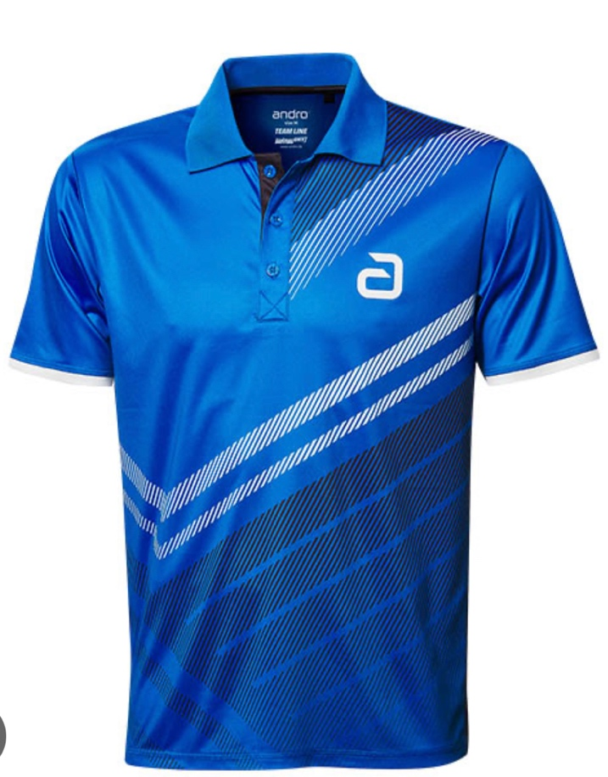

**Chemisette du club**

**2022/2023**

**Pré-commande**

|  |  |  |  |  |
| --- | --- | --- | --- | --- |
| Nom Prénom | Chemisette | |  | |
| Quantité | Taille | Prix | Total |
|  |  |  | 35 € |  |
|  |  |  |  |  |
|  |  |  |  |  |
|  |  |  |  |  |
|  |  |  |  |  |

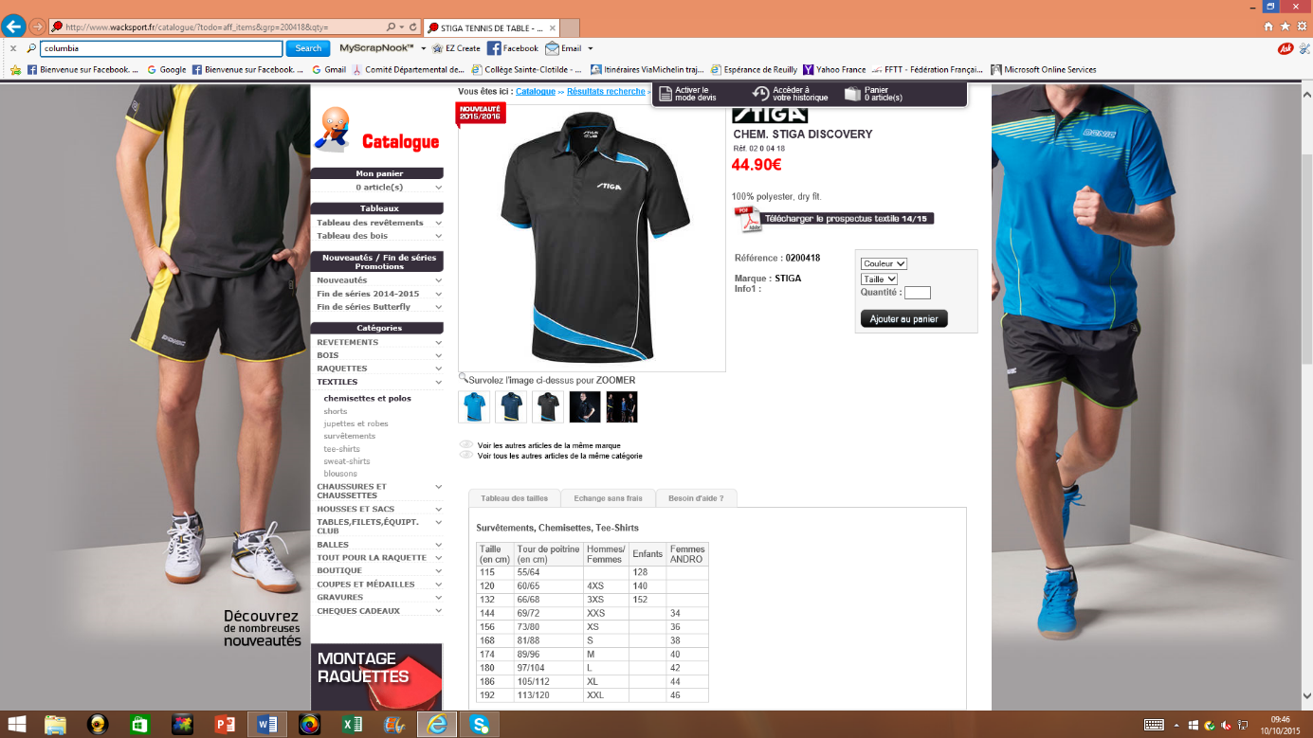

**Guide des tailles**